APPLICATION FOR ‘SPECIAL CASH PACKAGE SCHEME’ IN LIEU OF LTC
- Name of the Government servant : _____________________________________
- Designation & grade Pay : _____________________________________
- Current Pay & Pay Level : _____________________________________
- Department : _____________________________________
- Date of appointment in the Institute : _____________________________________
- Place of hometown as declared in the Service Book: __________________________________
- Particulars of LTC availed for the previous Block Years: ___________________
Please tick : (i) Hometown
(ii) Anywhere in India

- Please mention the current Block Year/’s of LTC to be availed in lieu of ‘Special Cash Package’: ___________________________
Please tick : (i) Hometown
(ii) Anywhere in India

9. Particulars of Govt. Servant & his/her family members availing the facility:
Sr. No. | Name | Relationship | Age  (in years) | Whether dependent (Yes/No) | * Deemed LTC fare per person (as per DoE OM dated 12.10.2020)
1
2
3
4
 |  |  |  | Total
* Employees entitled for Business Class of airfare – ₹36,000/- per person, Economy class ₹20,000/- per person, Rail fare of any class- ₹6,000/- per person.
10. Whether want to avail Leave Encashment against this LTC: Yes/No
11. Whether Advance is requested: Yes/No
12. Whether spouse is employed and if so whether entitled to LTC: Yes/No
Signature of Employee
DECLARATIONS
- I ___________________________________________ hereby certify that the above particulars furnished by me are true and correct.
- I also undertake to refund the advance in full immediately in case of non-purchase of the goods/services for which advance is taken.
- That my spouse is not employed in government. That my Spouse is employed in Government Service and this has not been availed of by him/her separately for himself/ herself or for any of the family members.
- Certified that my wife/ husband against whom this scheme is claimed by me is employed in______________________________________________(Name of the Public Sector Undertaking/ Corporation/ Autonomous body etc.) which provides leave Travel Concession facilities but he/she has not preferred and will not prefer, any claim in this behalf from his/her employer.
- Persons in respect of whom LTC is proposed to be availed are dependent on me.
- I understand that the advance taken under the scheme should be settled on or before 31.03.2021.
- I understand that the non-utilization/ under- utilization of advance will be accounted in accordance with the extant provisions relating to LTC advance i.e. immediate recovery of full advance in case of non-utilization and recovery of unutilized portion of the advance with penal interest.
- I understand that the Invoice (from GST registered vendors/ service providers) which to be submitted for reimbursement under this scheme should be in my name or in the name of my spouse or my family member who is eligible for LTC fare. Further, I understand that the payment of the expenses have to be made through digital mode only. A copy of the proof of the payment via digital mode will be also be submitted by me for reference. The invoice/ voucher should have the GST number of vendor and also indicate the amount of GST paid.
- I understand that the goods/services to be purchased under this scheme should carry a GST of 12% or above. The details of the GST should be clearly mentioned in the Invoice submitted.
- I understand that in case of EL encashment, an amount equivalent to the value of leave encashment needs to be spent on the purchases of goods/ services.
- I understand that an amount of three times of the cash equivalent of deemed fare needs to be spent on the purchase of goods/ services.

Signature of Employee

Forwarded through HOD/Section Head

Verification and Forwarding from ESTABLISHMENT SECTION

Details have been verified from the records and recommended / not recommended for ‘Special Cash Package Scheme’ in lieu of LTC for the amount Rs. _______________ (in words ________________________________________________).
In case of requirement of advance, recommended amount as per the scheme is Rs. ____________ (in words ________________________________________________).

AR (Establishment) Joint Registrar

RECOMMENDATION/ REMARKS OF THE DEAN (FW)
The ‘Special Cash Package Scheme’ in lieu of LTC is recommended for sanction/ not sanction and forwarded for approval of the Director.
In case of Advance, the amount recommended for sanction is Rs. ____________________________________

DEAN (F/W)

(Approved/ Not Approved)

DIRECTOR

Note:

- Multiple Bills are accepted, however, as far as possible, the number of transactions may be limited to a minimum extent to avoid any difficulty in processing the same.
- The employee need not have to take leave to avail this special cash package scheme in lieu of LTC.
- The reimbursement will be based on the production of invoice with details of GST and the claim should be made and settled well before 31.03.2021.
- In case of EL encashment, an amount equivalent to the value of leave encashment needs to be spent on the purchases of goods/ services.
- An amount of three times of the cash equivalent of deemed fare needs to be spent on the purchase of goods/ services.
- I understand that the non-utilization/ under- utilization of advance will be accounted in accordance with the extant provisions relating to LTC advance i.e. immediate recovery of full advance in case of non-utilization and recovery of unutilized portion of the advance with penal interest.
- The FAQs on the matter as promulgated by the DoE OM dated 20.10.2020 is enclosed.

APPLICATION FOR ENCASHMENT OF EARNED LEAVE UNDER ‘SPECIAL CASH PACKAGE’ IN LIEU OF LTC

1. Name of the Government servant :
2. Designation :
3. Department :
4. EL Encashment against LTC for the Block Year :
(Kindly enclose the current LTC order copy with this application.)
5. (i) Pay :
(ii) DA :
(iii) Total :
6. This will be my 1st ⁪ 2nd⁪ 3rd⁪ 4th⁪ 5th⁪ 6th⁪ EL Encashment of LTC.

Recommended & Forwarded by HOD Signature of the Govt. Servant
For office use only
EL Balance at Credit :___________Days.
Verified that this will be his/her ___________ EL Encashment for LTC against the LTC block year/year_______________.
Cash equivalent = Basic pay on the date of availing LTC + DA
30
X 10days
+
X 10
=
30
=

Amount in Words: ___________________________________________________________________________________
___________________________________________________________________________________

Prepared by
Submitted for approval
Assistant Registrar Joint Registrar
(Establishment Section)

(Recommended/Not Recommended) (Approved/Not Approved)
Registrar Director

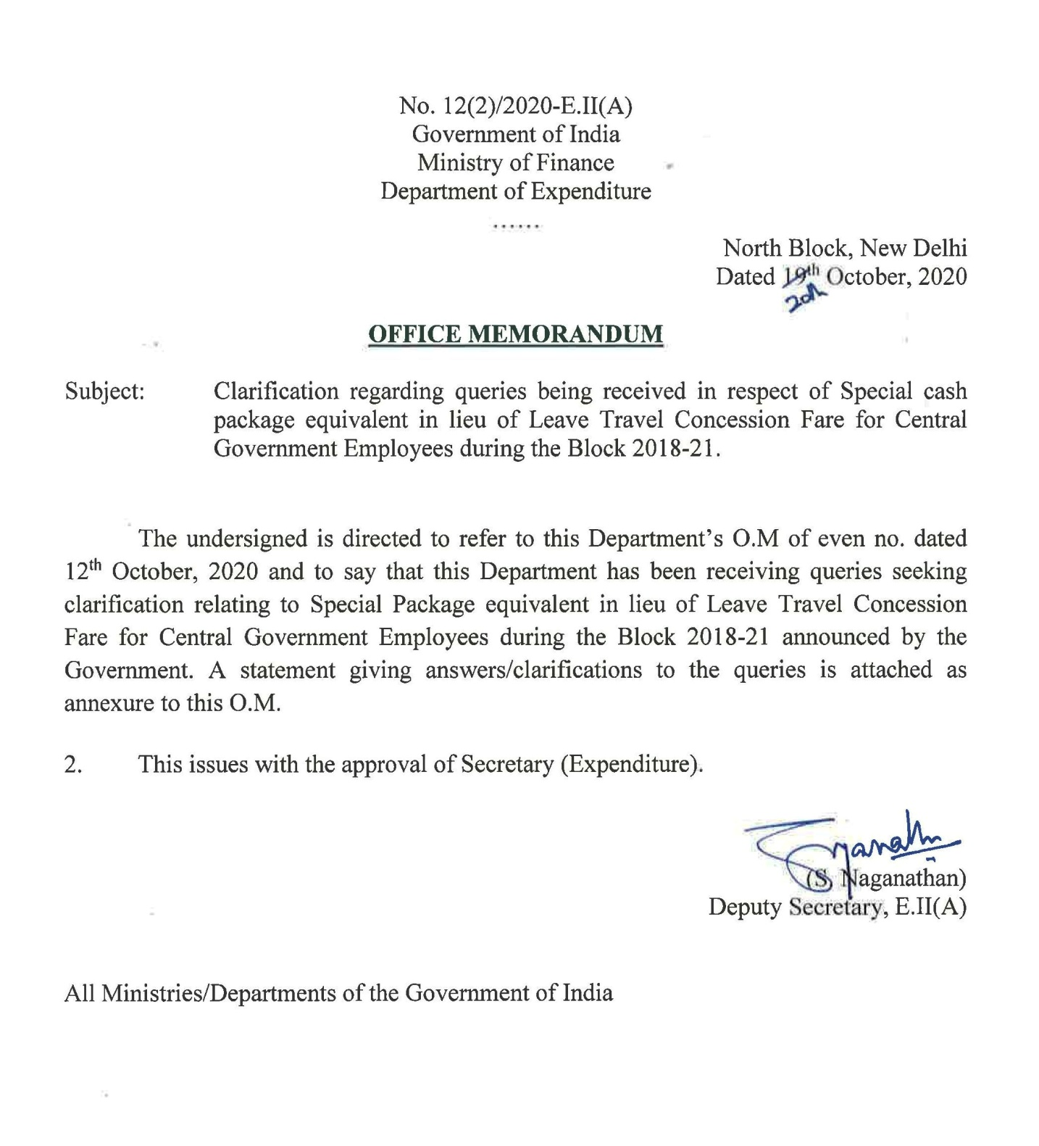

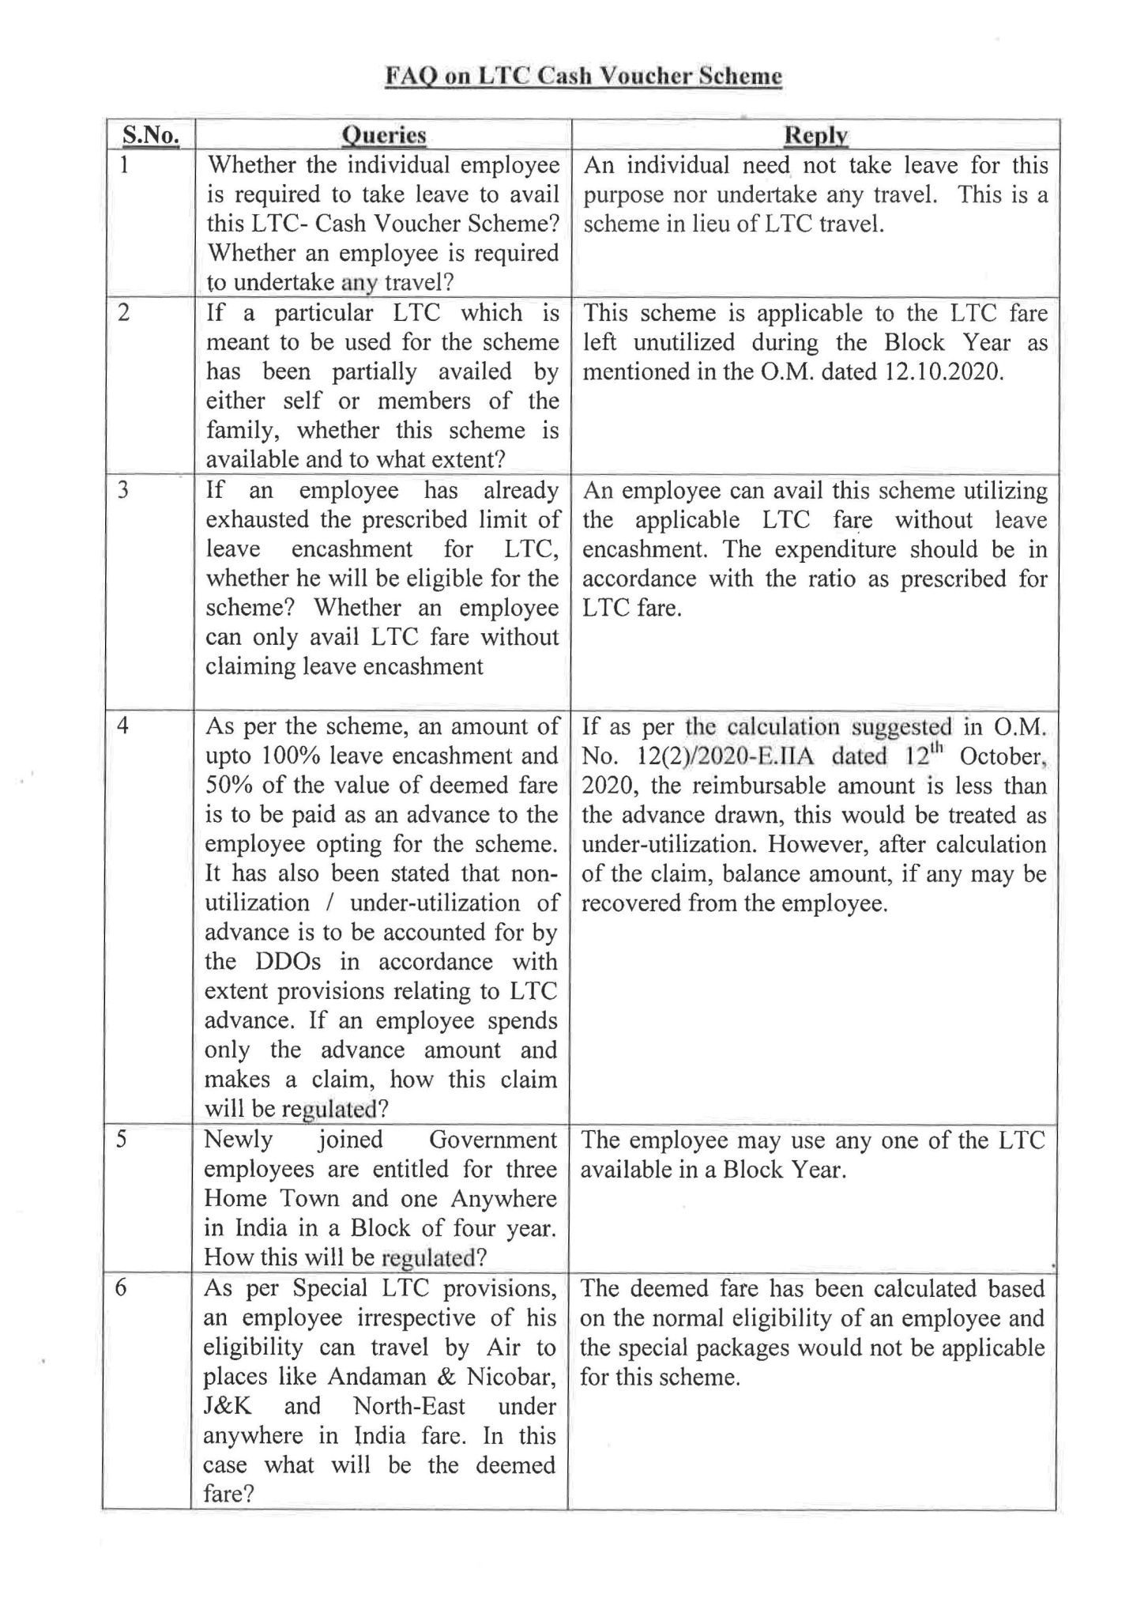

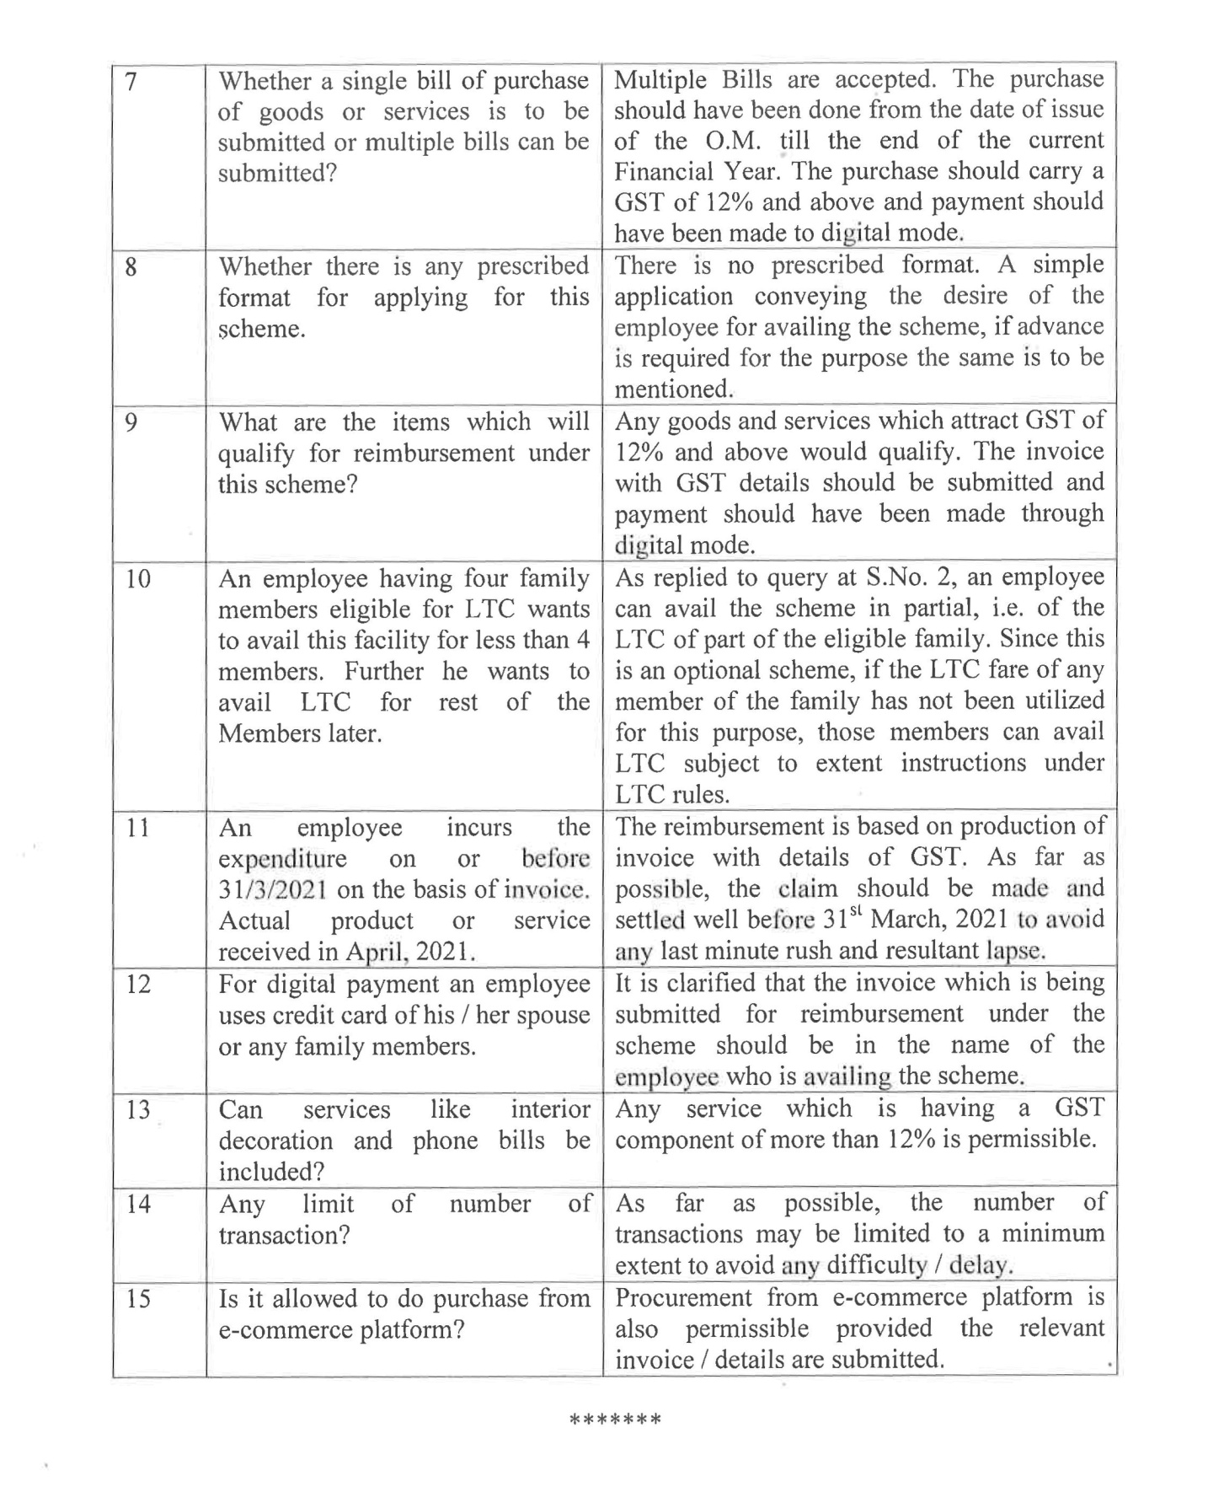

Information of LTC Block Years
Employees | Joining Year | Current Block Year | 1st LTC Year | 2nd LTC Year | 3rd LTC Year | 4th LTC Year
For Old Employees | up to 2012 | 2018-2021 | 2018-19 |  | 2020-21
For New Employees | 2013 | 2018-2021 | 2018 | 2019 | 2020 | 2021
 | 2014 | 2019-2022 | 2019 | 2020 | 2021 | 2022
 | 2015 | 2020-2023 | 2020 | 2021 | 2022 | 2023
 | 2016 | 2017-2020 | 2017 | 2018 | 2019 | 2020
 | 2017 | 2018-2021 | 2018 | 2019 | 2020 | 2021
 | 2018 | 2019-2024 | 2019 | 2020 | 2021 | 2022
 | 2019 | 2020-2023 | 2020 | 2021 | 2022 | 2023
 | 2020 | 2021-2024 | 2021 | 2022 | 2023 | 2024

